Project Report: COMPARATIVE FLOOD RISK AND VULNERABILITY ASSESSMENT

A GIS-Based Comparison of Hardoi District, Uttar Pradesh and Cachar District, Assam

Study Submitted by: 02: Manas Badiwale
06: Ashish Chaurasiya
07: Sanavi Chorge 11: Vedant Dhotre 16: Kashvi Gautam

TE-A COMPS 2026

DECLARATION
This report presents an original comparative analysis of two supplied GIS map outputs: the “Flood Risk Analysis Hardoi 2025” map and the “GIS-Based Flood Vulnerability Assessment of Cachar District, Assam” map. The comparison, tables, workflow diagram, figures, and written interpretation have been prepared specifically for this project.
The report does not reproduce another project report. Published research is used only to establish the theoretical background, identify methodological practices, and provide a basis for comparison. Wherever published numerical distributions are discussed, they are explicitly identified as supporting-study values and are not presented as measurements extracted from the supplied maps.
All final map layouts and analytical outputs used for submission should be checked by the project group against the original GIS project files and, where required, regenerated from the group's own spatial datasets.

ACKNOWLEDGEMENT
This project was developed to examine how GIS-based flood mapping can be used to compare spatial patterns of flood risk and vulnerability across two geographically different Indian districts. The supplied maps provide the principal visual evidence for the comparison.
The study also draws on published research concerning GIS, remote sensing, Analytical Hierarchy Process (AHP), multi-criteria decision-making, and flood susceptibility mapping. These sources helped establish the methodological context without replacing the supplied map outputs.
The report structure has been designed to separate observed map evidence, supporting literature, methodological reasoning, findings, and interpretation. This separation is important because the two supplied maps are not identical in terminology or documented analytical parameters.

ABSTRACT
Flood risk and flood vulnerability are spatially uneven because flooding is influenced by terrain, drainage, rainfall, river proximity, land cover, settlement patterns and other environmental and human factors. This study presents a comparative GIS-based assessment of two supplied map outputs: Flood Risk Analysis of Hardoi, Uttar Pradesh, dated 2025, and GIS-Based Flood Vulnerability Assessment of Cachar District, Assam.
Both maps use five qualitative classes ranging from Very Low to Very High, allowing a common visual framework for comparison. The Hardoi map shows a pronounced presence of High and Very High categories, including elongated and clustered patterns associated with major drainage corridors and several interior patches. The Cachar map shows a broad distribution of Moderate and High vulnerability, with Very High zones concentrated in several central, eastern and southern portions and lower classes more visible in northern and peripheral areas.
The comparison indicates that the two districts exhibit different spatial expressions of flood susceptibility/vulnerability. Hardoi presents a more strongly concentrated high-risk visual pattern, while Cachar displays a more spatially continuous transition across moderate-to-high vulnerability with localized very-high clusters. These observations are descriptive and are based on the supplied maps; exact class-area percentages cannot be calculated from the map images alone.
Published research supports the use of GIS-MCDM and AHP for flood susceptibility mapping and shows that parameters such as elevation, slope, rainfall, drainage density, distance from rivers, land use/land cover, NDVI, TWI and population can influence flood susceptibility. The study concludes that map comparison is useful for identifying spatial priorities, but direct numerical comparison requires harmonized datasets, identical classification rules, common spatial resolution and documented weights.

Table Of Content:
Chapter | Title | Page No.
Chapter 1 | INTRODUCTION | 5
1.1 | Background of the Study | 5
1.2 | Rationale for Comparative Assessment | 5
1.3 | Research Context | 6
Chapter 2 | LITERATURE REVIEW | 7
2.1 | Literature Analysis | 7
2.2 | Statement of the Problem | 9
2.3 | Objectives of the Research | 10
2.4 | Scope and Limitations | 10
2.5 | Study Area | 11
2.6 | Data Sources | 12
2.7 | Software and Tools | 13
Chapter 3 | METHODOLOGY | 14
3.1 | Research Design | 14
3.2 | Objective-Wise Methodology | 15
3.3 | Map Standardization | 15
3.4 | Spatial Pattern Analysis | 16
3.5 | Comparative Analysis | 16
3.6 | Validation and Uncertainty | 17
Chapter 4 | FINDINGS | 18
4.1 | Hardoi Map Findings | 18
4.2 | Cachar Map Findings | 20
4.3 | Side-by-Side Comparison | 21
4.4 | Supporting Quantitative Evidence | 22
Chapter 5 | RESULT AND DISCUSSION | 24
5.1 | Interpretation | 24
5.2 | Comparison with Literature | 24
5.3 | Recommendations | 26
5.4 | Conclusion | 26
 | References | 24

CHAPTER 1: INTRODUCTION

Background of the Study
Flooding is a recurrent natural hazard in many parts of India and its impacts are strongly controlled by local geography. A flood does not affect every location within a district equally. Low-lying terrain, proximity to rivers and streams, poor drainage, intense rainfall, high drainage density and human settlement can combine to increase exposure and potential damage. GIS provides a practical framework for integrating these spatial factors into a single decision-support environment.
The present project focuses on a comparative reading of two map products rather than attempting to reproduce an unknown original modelling workflow. The first supplied map is titled “Flood Risk Analysis Hardoi 2025”. It uses a five-class legend: Very Low Risk, Low Risk, Moderate Risk, High Risk and Very High Risk. The second supplied map is titled “GIS-Based Flood Vulnerability Assessment of Cachar District, Assam”. It also uses five classes: Very Low, Low, Moderate, High and Very High.
The common five-class structure creates an opportunity for comparative interpretation. However, the terms risk and vulnerability are not interchangeable. Risk normally combines hazard with exposure and/or vulnerability, whereas vulnerability describes the degree to which people, assets or systems may be susceptible to harm. Therefore, this report compares the spatial outputs while explicitly retaining the terminology used in each original map.
The Hardoi map has a scale bar extending to 16.4 km and presents the district as a compact study boundary with a simple north arrow. The Cachar map has a scale bar extending to 34 km and includes a district outline, a larger compass symbol and a clearer administrative boundary legend. These layout differences are relevant because cartographic design affects how spatial patterns are read.

Rationale for Comparative Assessment
A single flood map is useful for identifying priority areas, but comparison between districts provides a broader understanding of how similar classification schemes can produce different spatial patterns. Hardoi and Cachar are geographically distinct. Hardoi lies in the northern Indian plain environment of Uttar Pradesh, whereas Cachar is in southern Assam and is strongly associated with the Barak River system and a humid monsoon setting. The comparison is valuable for three reasons. First, it identifies common spatial signatures such as concentration of higher classes around drainage-related corridors. Second, it identifies differences in the continuity and distribution of higher-risk classes. Third, it highlights an important GIS principle: map outputs cannot be compared numerically unless their input data, spatial resolution, weighting system, classification thresholds and validation procedures are compatible.
The supplied Hardoi map visually contains numerous red Very High Risk patches and elongated high-risk structures. The supplied Cachar map shows a large orange-red transition zone, with strong red concentrations in several parts of the district and comparatively greener zones toward parts of the northern and peripheral landscape. These visual differences form the central evidence base of this report. The project therefore treats the maps as spatial evidence rather than as interchangeable statistical datasets. Where numerical values from published studies are introduced, they are presented separately as supporting evidence. This approach reduces the risk of assigning unsupported statistics to the supplied map images.

Research Context
Modern flood susceptibility studies increasingly combine remote sensing, GIS and multi-criteria decision-making. Recent Indian studies have used AHP to assign relative importance to flood-conditioning parameters and weighted-overlay methods to produce five-class susceptibility maps. The published Cachar study, for example, evaluated ten factors including elevation, slope, precipitation, LULC, NDVI, TWI, distance from roads, distance from rivers, drainage density and population density. [1]
The wider literature demonstrates that flood mapping is not only a cartographic exercise. It is a modelling problem in which the selection and weighting of variables determine the final spatial pattern. Consequently, a comparison report must examine both what the maps show and what cannot be inferred from the map images.
This study adopts a descriptive-comparative design. It records the visible distribution of five flood classes, compares spatial concentration and continuity, examines cartographic characteristics, reviews supporting literature, and develops recommendations for improving future comparative flood assessments.

CHAPTER 2: LITERATURE REVIEW

Literature Analysis
The literature review focuses on studies that use GIS, remote sensing, AHP or related multi-criteria methods for flood susceptibility, vulnerability and risk mapping. The selected papers provide methodological foundations for understanding the two supplied maps.

Paper / Study | Method | Main contribution | Gap relevant to this project
Borah et al.  (2025), Cachar, Assam | GIS + AHP +  MCDM; 10 factors | Five flood-susceptibility zones; vulnerability examined using population density | A district-specific model cannot automatically be compared numerically with another district model unless inputs and weights are harmonized.
Assam regional flood-risk study (2022) | MCDA-AHP;  hazard, vulnerability and risk indices | Developed FHI, FVI and FRI at  regional/administrative levels | Regional indices depend on indicator selection and  weighting; direct transfer to Hardoi is not justified.
Krishna District study (2022) | RS + GIS + AHP; 11  factors | Integrated terrain, drainage, rainfall, LULC and stream-distance variables | AHP is transparent but still dependent on expert/literature-based weights.
Idukki District study (2023) | AHP with 12 flood-contributing parameters;  AUC-ROC  validation | Mapped high/very-high susceptibility and  validated using ROC-AUC | Validation requires an independent flood inventory; map images alone do not provide this.
Savitri Basin study (2026) | GIS-AHP with 10 factors | Integrated elevation, slope, precipitation, drainage density, TWI, LULC, soil and other variables | Authors note limitations from expert weighting and absence of dynamic  hydrodynamic modelling.

Study 1: Cachar District, Assam
Borah, Handique, Dutta, Bori, Acharjee and Longkumer (2025) assessed flood susceptibility in Cachar District using GIS-based multi-criteria decision-making and AHP. The study selected ten contributing factors: elevation, slope, precipitation, LULC, NDVI, TWI, distance from road, distance from river, drainage density and population density. Five susceptibility classes were produced. The published study reports 31.24% Very Low, 35.73% Low, 19.74% Moderate, 10.79% High and 2.48% Very High susceptibility. It also overlaid susceptibility with population density to understand vulnerability. [1]
This paper is particularly important because the second supplied map is explicitly a GIS-based flood vulnerability assessment of Cachar. The study demonstrates how physical susceptibility can be combined with demographic exposure. It also provides a methodological warning: a susceptibility map and a vulnerability map answer related but different questions.
For the present comparison, the paper provides context for interpreting the Cachar map, but the supplied map itself is treated as the primary visual source. The published percentages are not assumed to be pixel counts derived from the supplied image; they are reported study values.

Study 2: GIS-Based Flood Risk Mapping of Assam
A regional Assam study applied multi-criteria decision analysis and AHP to develop flood hazard, vulnerability and risk indices. The study considered topographical, geological, meteorological, drainage, land-use/land-cover and demographic characteristics. It reported that more than 70% of the region fell within moderate-to-very-high flood hazard classes, while 57.37% and 50% were within moderate-to-very-high vulnerability and risk classes respectively. [2]
The study is useful for the present report because it separates hazard, vulnerability and risk. This distinction reinforces the need to avoid treating the labels on the two supplied maps as perfectly equivalent. A map labelled risk may include exposure and vulnerability components, while a map labelled vulnerability may be dominated by social or physical susceptibility indicators.
The main gap relevant to this project is cross-district comparability. A model designed for Assam may use region-specific variables and weights that are not appropriate for Hardoi. Therefore, the present project compares spatial patterns and methodological implications rather than declaring one district universally more flood-prone than the other.

Study 3: Krishna District, Andhra Pradesh
A GIS-enabled AHP study of Krishna District integrated remote sensing and GIS with eleven factors: elevation, slope, aspect, LULC, drainage density, TWI, stream power index, lithology, soil, precipitation and distance from streams. The work demonstrates the value of combining terrain, hydrology and land-surface characteristics rather than relying on a single flood indicator. [3]
The Krishna study supports the interpretation that high-risk patterns should be examined in relation to physical controls. For example, lower elevation and gentle slopes can encourage water accumulation, while proximity to streams increases the probability of direct inundation. Land-cover conditions may further modify runoff and infiltration.

A limitation is that AHP-based weighting remains dependent on the selected criteria and the judgement used to assign relative importance. Two research teams using different weights may produce different maps from the same basic data. This is directly relevant to a comparison of Hardoi and Cachar.

Study 4: Idukki District, Kerala
The Idukki study used AHP to weight twelve flood-contributing parameters and generated a flood susceptibility map. Validation through the AUC-ROC approach produced an accuracy of 0.91, demonstrating the importance of independent validation when a susceptibility map is used for decision-making. [4]
The methodological lesson for the present project is that visual plausibility alone is not sufficient to establish model accuracy. A map may contain visually coherent high-risk zones while still requiring historical flood observations to test whether those zones correspond to actual inundation events.
The present supplied maps do not include their original validation statistics. Therefore, this report does not assign an accuracy value to either map. A future version of the project should compare both maps against a common flood inventory derived from satellite observations or official inundation records.

Study 5: Recent GIS-AHP Research
Recent research continues to refine GIS-AHP flood mapping. A 2026 Savitri River Basin study incorporated ten factors including elevation, slope, distance from river, distance from roads, precipitation, drainage density, NDVI, TWI, LULC and soil texture. The authors reported that elevation, precipitation and drainage density were among the primary influences and highlighted the value of a structured AHP framework. [5]
A 2026 Damodar River Basin study further extended GIS-AHP by integrating additional indicators such as NDWI and surface roughness to improve spatial detail. [6] These recent studies indicate a trend toward combining traditional susceptibility variables with indicators derived from remote sensing and surface characteristics.
The literature gap that remains relevant to the present project is the need for standardized comparative frameworks. A map comparison should ideally use the same projection, cell size, factor definitions, normalization scheme, weighting process and validation dataset. Without this harmonization, visual comparison remains useful but quantitative ranking is uncertain.

Statement of the Problem
Flood-risk maps are increasingly used to support planning and disaster management, but maps produced for different districts may use different definitions, input factors, scales and classification methods. Comparing such maps without identifying these differences can lead to misleading conclusions.
The specific problem addressed by this study is therefore: How do the spatial patterns of flood risk/vulnerability shown for Hardoi District and Cachar District differ, what common patterns can be identified, and what methodological limitations must be considered before treating the two maps as quantitatively comparable? A map may visually show a large amount of red or orange, but the viewer needs to know whether the colour represents physical hazard, social vulnerability, integrated risk, or a susceptibility score. The report therefore evaluates both spatial content and map terminology.

Objectives of the Research
- To examine the spatial distribution of five flood-risk/vulnerability classes in the supplied Hardoi and Cachar maps.
- To identify areas where Very Low, Low, Moderate, High and Very High categories are visually concentrated.
- To compare the spatial continuity, clustering and corridor patterns of higher-risk classes between the two districts.
- To compare the cartographic design, legends, scale indicators and map communication features of the two outputs.
- To review GIS, remote-sensing and AHP-based flood literature relevant to interpretation of the maps.
- To distinguish map-derived observations from externally reported numerical evidence.
- To identify limitations that prevent direct numerical comparison of the two supplied maps.
- To provide evidence-based recommendations for future GIS flood-risk mapping and validation.

Scope and Limitations
The scope covers comparative interpretation of the two supplied district-level map outputs, supported by published literature and contextual official information. The study does not attempt to reconstruct the original GIS models because the supplied PDFs contain map images but not the underlying raster layers, attribute tables, factor weights, reclassification thresholds or processing metadata.
The most important limitation is therefore data comparability. The Hardoi map is labelled Flood Risk Analysis, while the Cachar map is labelled Flood Vulnerability Assessment. The terms describe different analytical concepts. In addition, the maps use different scale-bar ranges and different cartographic layouts.
- No pixel-level class areas were calculated from the supplied images.
- No unsupported percentage was assigned to the Hardoi map.
- Published numerical values are clearly separated from visual observations.
- Original GIS layers and model weights were not available in the supplied PDFs.
- No independent accuracy assessment was performed for the supplied map outputs.
- Temporal comparability is limited because the Hardoi map is explicitly dated 2025, while the Cachar map does not display a comparable map-production year.
- Colour similarity does not prove that the same numerical susceptibility ranges were used.

Study Area

Hardoi District
The supplied Hardoi map represents the district-level flood-risk pattern in Uttar Pradesh and is titled “Flood Risk Analysis Hardoi 2025”. The map shows a compact district boundary and a five-class risk legend. The spatial pattern includes numerous high-intensity red areas and elongated structures that appear aligned with drainage or river-related corridors. Lower-risk green and blue areas occur in several peripheral and interstitial zones.
Official flood-mapping records also demonstrate that Hardoi has experienced mapped inundation during recent flood events. A National Remote Sensing Centre record for July 2024 includes parts of Hardoi in a satellite-based flood-inundation product. An Uttar Pradesh disaster-management report also classifies Hardoi as a flood-sensitive district. These sources provide contextual support for treating the supplied Hardoi map as a meaningful disaster-management output, although they do not validate the exact pixel pattern of the supplied map.

Cachar District
The supplied Cachar map represents Cachar District in Assam and is titled “GIS-Based Flood Vulnerability Assessment of Cachar District, Assam”. The map includes a district boundary, five vulnerability classes, a north-oriented compass symbol and a scale bar extending to approximately 34 km.
The published Cachar study describes the district as a recurring flood-affected area drained by the Barak River and identifies ten factors used for GIS-AHP susceptibility assessment. The study reported five susceptibility zones and subsequently examined population density to understand vulnerability. [1]
Visually, the supplied map shows lower vulnerability in parts of the northern and peripheral landscape, while orange and red categories are widespread across central and eastern portions. Strong Very High clusters appear in the central and southern portions. The pattern therefore contains both broad transition zones and localized high-intensity clusters.

Data Sources

Data Description | Data Type |  |  | Data Source
Hardoi flood-risk map, 2025 | Raster map / PDF image |  |  | Supplied project map
Cachar flood-vulnerability map | Raster map / PDF image |  |  | Supplied project map
Published Cachar flood-susceptibility study | Research paper |  |  | Natural Hazards Springer-indexed record | /
Assam regional flood-risk research | Research paper |  |  | Taylor & Francis / Geocarto International
Krishna District flood susceptibility study | Research paper |  |  | Peer-reviewed journal PubMed record | /
Idukki flood susceptibility study | Research paper |  |  | Journal of Spatial Science
Hardoi satellite flood context | Official document | satellite | mapping | NRSC / ISRO
Hardoi flood-sensitivity context | Government  disaster-management report |  |  | UP State Disaster Management Authority
The primary visual datasets are the two supplied map PDFs. External sources are used only for methodological context, literature review and supporting disaster context. This distinction is maintained throughout the report.

Softwares and Tools

Tool | Purpose
ArcGIS / ArcGIS Pro | Map preparation, raster processing, reclassification, weighted overlay and layout design where applicable
QGIS | Alternative GIS environment for raster/vector processing and cartographic layout
Remote sensing datasets | Extraction of environmental variables such as vegetation, water and land-cover information
Python | Optional statistical processing, chart generation and reproducible comparison tables
Microsoft Word / LibreOffice | Report preparation and documentation
Google Earth Engine | Optional large-scale satellite preprocessing and time-series analysis
AHP / MCDA framework | Weight assignment and multi-criteria integration when reconstructing a comparable model

CHAPTER 3: METHODOLOGY

Research Design
The study follows a comparative spatial-analysis design. It begins with acquisition and inspection of the two supplied maps, followed by classification harmonization, visual pattern extraction, supporting literature review, comparative interpretation, limitation assessment and recommendation development.
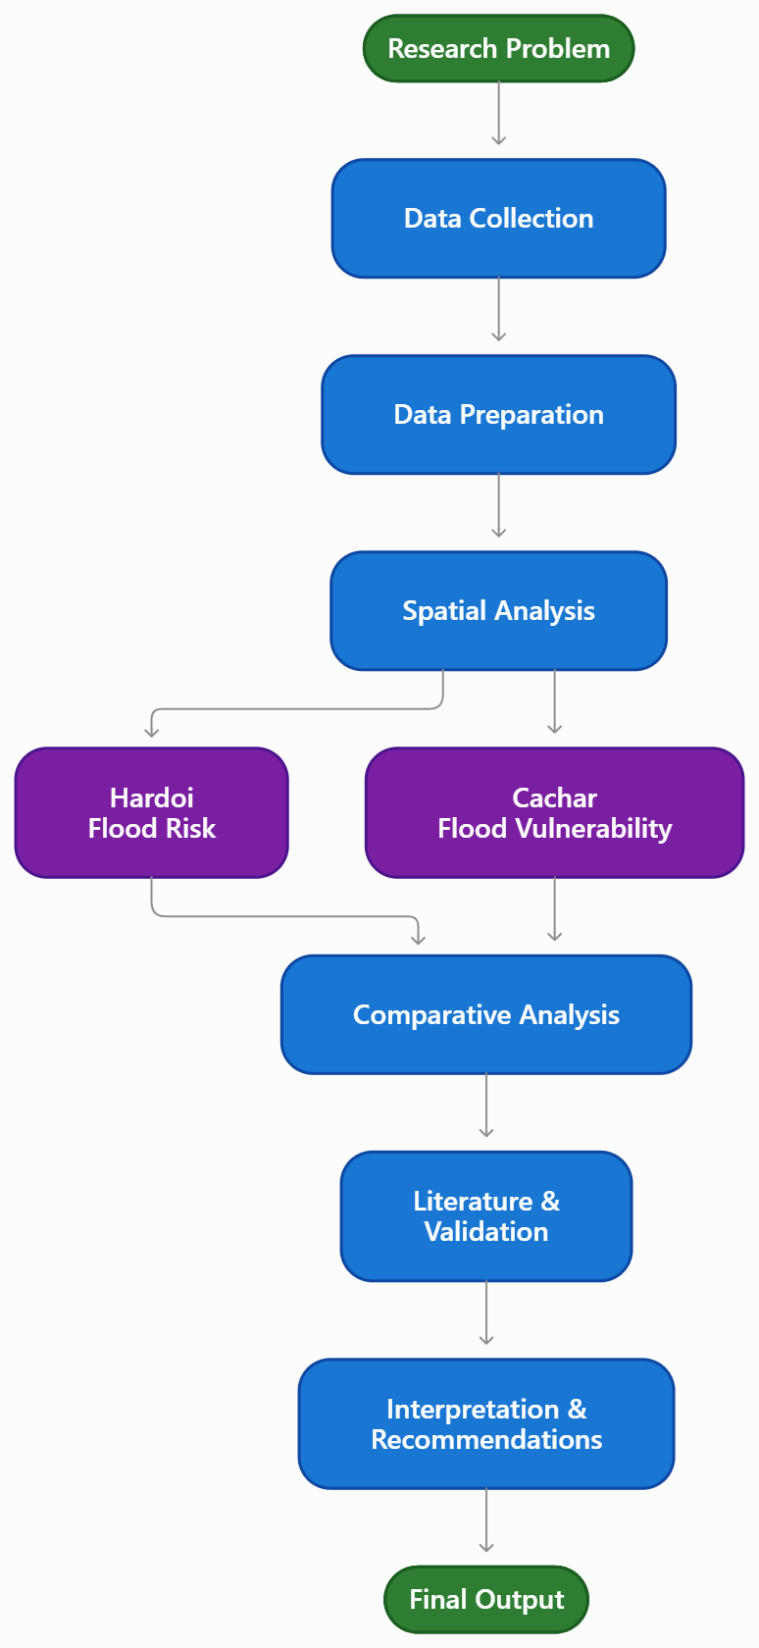

Figure 3.1. Original research workflow prepared for the comparative flood-mapping study.

The workflow deliberately separates observation from interpretation. First, the visible map pattern is recorded. Only after this step are possible environmental explanations discussed. This prevents the report from treating an assumed modelling factor as if it were explicitly present in the supplied map.

Objective-Wise Methodology

Objective 1: Examine spatial distribution of flood classes
The five-class legends of both maps were recorded and placed into a common comparison framework: Very Low, Low, Moderate, High and Very High. For each map, the approximate location and visual concentration of each class were documented. The analysis did not convert colours into area percentages because the source images do not provide class-area statistics.

Objective 2: Identify concentration zones
The maps were visually divided into broad sectors—north, south, east, west and central/interior. High and Very High patches were identified according to their apparent clustering, continuity and relation to visible drainage-like structures or landscape boundaries. The purpose was to describe spatial organisation rather than to infer exact causation.

Objective 3: Compare higher-risk patterns
The comparison considered three dimensions: intensity, continuity and concentration. Intensity refers to the relative presence of High and Very High colours. Continuity refers to whether higher categories form connected belts or isolated patches. Concentration refers to whether they occur in specific corridors or across broad portions of the district.

Map Standardization
Before comparing the two maps, their legends were translated into a common semantic scale. The class names were retained in their original terminology, but their ordinal position was standardized from 1 to 5 for descriptive comparison only. This ordinal coding does not imply that the underlying numerical scores are equal.

Common Level | Hardoi Legend | Cachar Legend | Interpretation for comparison
1 | Very Low Risk | Very Low | Lowest mapped category
2 | Low Risk | Low | Low mapped category
3 | Moderate Risk | Moderate | Intermediate mapped category
4 | High Risk | High | Elevated mapped category
5 | Very High Risk | Very High | Highest mapped category
The key methodological rule is that ordinal standardization permits comparison of class position but not comparison of numerical score magnitude. For example, a Very High value in Hardoi cannot be assumed to represent the same numerical susceptibility range as Very High in Cachar.

Spatial Pattern Analysis
Spatial pattern analysis was performed through visual interpretation of the supplied map images. Four pattern characteristics were recorded: cluster density, corridor alignment, edge-to-interior contrast and transition smoothness.
    - Cluster density: number and visual concentration of high-intensity patches within a broad district sector.
    - Corridor alignment: elongated high-intensity features that appear to follow drainage, river or terrain structures.
    - Edge-to-interior contrast: difference between peripheral lower classes and central higher classes.
    - Transition smoothness: whether classes change gradually across space or appear as sharply bounded patches.
The approach is appropriate for the available evidence but should not be mistaken for a formal spatial-statistical test. A formal test would require the original raster cells and spatial coordinates.

Comparative Analysis
The comparative framework uses a matrix containing location, dominant visible classes, higher-risk concentration, low-risk concentration, drainage relationship, cartographic features and data limitations. Each criterion was evaluated independently for Hardoi and Cachar.

Criterion | Hardoi | Cachar
Map concept | Flood Risk Analysis | Flood Vulnerability Assessment
Classes | Very Low–Very High | Very Low–Very High
Highest-class appearance | Numerous red clusters and elongated high-intensity zones | Strong red clusters within broader orange-red areas
Lower-class appearance | Green/blue zones visible around and between high-risk areas | Green/light zones more visible in northern and peripheral areas
Spatial character | Patchy but strongly high-risk dominated | Broad moderate/high field with localized very-high clusters
Scale-bar maximum | 16.4 km | 34 km
Cartographic emphasis | Simple district risk map | Administrative district + vulnerability presentation
Direct area comparison possible? | No, not from image alone | No, not from image alone

Validation and Uncertainty
Validation is a critical part of flood susceptibility modelling. Published studies have used historical flood points, ROC-AUC analysis, satellite inundation records and other independent evidence. The supplied maps do not include their validation tables or accuracy statistics. Consequently, this report does not claim that one map is more accurate than the other.
A future validation procedure should create a common flood-inventory dataset from official satellite-derived inundation maps or verified historical flood observations. The same validation points should then be sampled against each model, and ROC-AUC, precision, recall or confusion-matrix measures can be calculated where appropriate.
Uncertainty also arises from classification thresholds, temporal mismatch, map resolution and the possibility that one model emphasizes physical susceptibility while another incorporates exposure. These factors must be documented before the outputs are used for investment, evacuation or land-use decisions.

CHAPTER 4: FINDINGS

Hardoi Map Findings
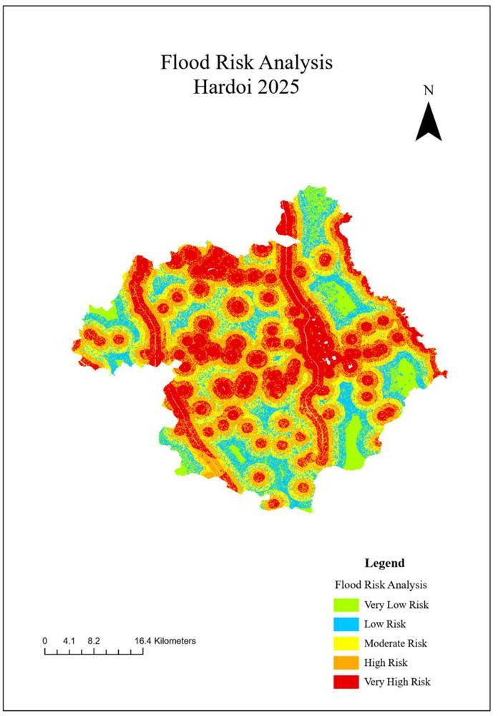

Figure 4.1. Supplied map: Flood Risk Analysis, Hardoi 2025.

The Hardoi map contains five risk classes from Very Low Risk to Very High Risk. The red Very High Risk category is visually prominent and appears in numerous compact clusters as well as elongated structures. Several of these elongated areas form broad north-south or diagonal patterns, suggesting strong spatial organization rather than random distribution.
Green Very Low Risk and blue Low Risk areas occur in several peripheral and interstitial locations. Yellow Moderate Risk and orange High Risk classes provide transition zones between lower and higher categories. The map therefore displays a multi-scale pattern in which high-risk clusters are embedded within broader moderate or low-risk areas.

Hardoi Spatial Characteristics
A notable characteristic of the Hardoi map is the strong visual contrast between red high-intensity patches and green/blue lower-intensity areas. The central portion contains many high-risk clusters, while additional elongated high-risk patterns extend through the district. The red category is not restricted to a single isolated boundary.
The map's scale bar reaches 16.4 kilometres, indicating that the displayed district occupies a relatively compact cartographic frame. The legend is placed in the lower-right portion and uses a sequential visual progression from green to red. This colour ordering makes the highest category visually dominant and easy to identify.
Because no river labels, roads or settlements are shown on the supplied Hardoi map, the exact environmental cause of each red patch cannot be established from the image alone. A relationship with drainage is plausible in a flood-risk context, but it must be tested using the original GIS layers.

Cachar Map Findings
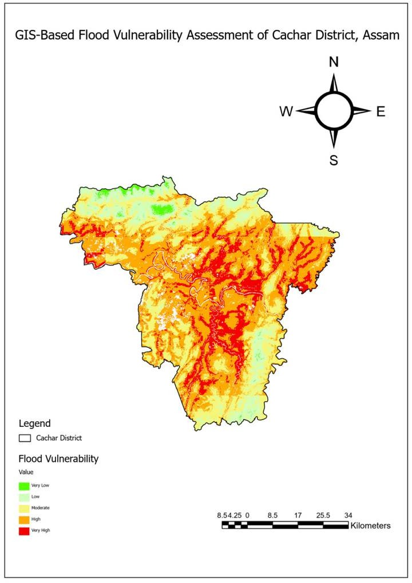

Figure 4.2. Supplied map: GIS-Based Flood Vulnerability Assessment of Cachar District, Assam.

The Cachar map uses the same five-level conceptual classification, progressing from Very Low to Very High. Unlike the Hardoi map, the district boundary is explicitly represented in the legend and the map uses a large four-direction compass symbol. The scale bar extends to approximately 34 kilometres.
The visual field contains extensive orange and yellow areas, with red Very High patches concentrated in several central, eastern and southern portions. Green Very Low areas are comparatively more visible toward the northern and peripheral landscape. The map therefore presents a strong moderate-to-high background with localized very-high concentrations.

Cachar Spatial Characteristics
The Cachar map shows several red linear or branching structures that appear spatially associated with drainage-like patterns. However, the map should not be used to claim a specific river relationship unless the underlying river layer is available. The published Cachar study identifies the Barak River and distance from the river as important contextual factors, but this report treats that as literature support rather than as direct evidence from every red pixel.
The map also shows a strong transition from greener northern areas toward more orange and red central/eastern areas. This spatial gradient is one of the clearest differences from the Hardoi output, where very high patches are more visually fragmented and numerous.

Side-by-Side Comparison

Feature | Hardoi | Cachar | Comparative observation
Highest category | Very High Risk | Very High | Both maps emphasize five-level classification.
Visual dominance | High and Very High colours are strongly visible | Moderate and High form a broad background with Very High clusters | Hardoi appears more strongly high-risk dominated visually.
Very High pattern | Numerous compact and elongated clusters | More concentrated central/eastern/southern clusters | Different spatial concentration.
Lower classes | Green/blue areas between higher patches | Green/light zones especially visible in north/periphery | Both retain  lower-risk areas, but their distribution differs.
Map scale | 16.4 km maximum | 34 km maximum | Different cartographic scale ranges.

Feature | Hardoi | Cachar | Comparative observation
Terminology | Risk | Vulnerability | Concepts are related but not identical.
Administrative boundary | Implicit study outline | Explicit Cachar District legend/boundary | Cachar communicates administrative context more explicitly.
Direct numerical comparison | Not supported by image | Not supported by image | Requires source rasters and metadata.
The central comparative finding is not that one district is universally “more dangerous” than the other. Instead, the two maps display different spatial structures. Hardoi is characterized by many high-intensity patches and corridors, whereas Cachar shows a broad moderate-to-high field containing localized very-high concentrations.

Supporting Quantitative Evidence
The following quantitative comparison is deliberately separated from the supplied map images. It uses values reported in supporting published studies. For Cachar, Borah et al. (2025) reported 31.24% Very Low, 35.73% Low, 19.74% Moderate, 10.79% High and 2.48% Very High susceptibility. [1] A separate supporting study of the Ramganga River Basin reported Hardoi's zonal distribution as 1.6% Very Low, 9.4% Low, 14.1% Moderate, 34.3% High and 40.5% Very High. These values should not be interpreted as measurements extracted from the supplied Hardoi map.
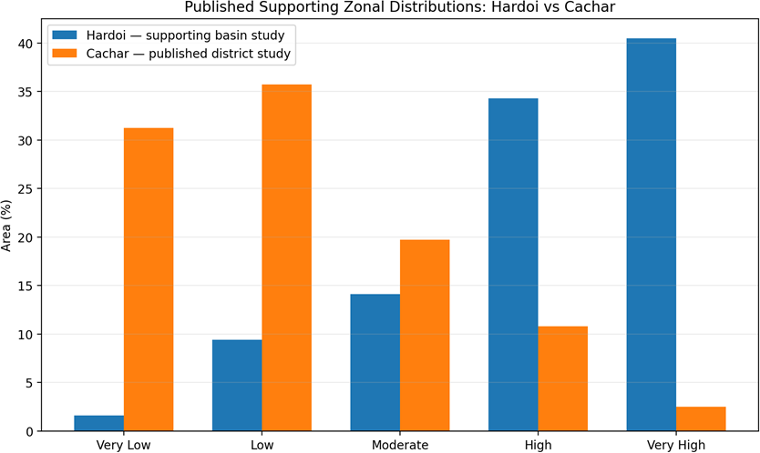

Figure 4.3. Supporting-study zonal distributions; values are not extracted from the supplied map images.

The supporting values indicate a large difference in the share of High + Very High classes: 74.8% for the referenced Hardoi basin study and 13.27% for the published Cachar district study. This contrast is informative but not a controlled comparison because the studies use different spatial contexts and methodologies.

High-to-Very-High Comparison
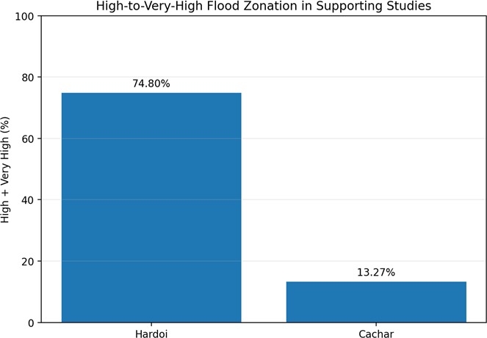

Figure 4.4. High + Very High percentage in supporting published studies.

The supporting-study chart shows why numerical values must be handled carefully. The Hardoi figure comes from a Ramganga River Basin analysis in which Hardoi is one district within a larger basin. The Cachar values come from a district-specific flood-susceptibility study. The spatial units and modelling frameworks are therefore different.
The appropriate use of these values is contextual rather than definitive. They support the visual impression that Hardoi has a substantial high-intensity flood-risk burden in some published analyses, while the Cachar study reports a much larger share in low and very-low susceptibility classes. They do not establish that the two supplied maps were generated from identical criteria.

CHAPTER 5: RESULT AND DISCUSSION

Analysis of the Comparative Findings
The comparison demonstrates that both districts contain spatially heterogeneous flood conditions. Neither map is uniformly high or uniformly low. Instead, each contains transitions between lower, moderate and higher classes. This heterogeneity is important for planning because it implies that flood management should be spatially targeted rather than applied identically across an entire district.
Hardoi's map is visually characterized by a greater concentration of red Very High Risk patches. The pattern includes both compact clusters and elongated structures. Such patterns are consistent with a landscape where flood risk may be controlled by multiple overlapping factors, including drainage pathways, topography and local land conditions. However, the supplied map does not show those input layers, so causal attribution remains outside the evidence available here.
Cachar's map has a different appearance. Large orange and yellow regions create a broad moderate-to-high background, while red Very High areas are concentrated in selected corridors and clusters. This suggests that the spatial transition between classes may be more gradual over larger parts of the district, with localized hotspots requiring particularly focused attention.

Interpretation of Spatial Variables
Flood mapping literature repeatedly identifies elevation and slope as important physical controls. Lower elevations can accumulate floodwater, while gentle slopes may reduce the rate at which water drains from an area. Distance from rivers and drainage density influence the probability that an area is connected to a flood pathway. Rainfall and precipitation influence the amount of water entering the system.
Land use and land cover affect runoff, infiltration and exposure. Built-up areas tend to have more impervious surfaces, while vegetation and soil conditions can modify infiltration and surface flow. Population density adds an exposure dimension when the goal is vulnerability rather than physical susceptibility.
These variables provide plausible explanations for patterns visible in the maps, but the report does not infer a specific variable-to-pixel relationship without the source layers. This distinction is particularly important for academic originality and methodological honesty.

Comparison with Literature
The spatial patterns observed in the supplied maps are broadly consistent with the literature's use of multi-factor GIS modelling. The Cachar map's concentration of higher vulnerability in central and southern/eastern areas is compatible with the published Cachar study, which reported that high-susceptibility areas overlapped with high population density and identified Silchar, Katigorah and Kalain as more vulnerable locations. [1]
The literature also supports the use of drainage, elevation, rainfall and distance from streams/rivers as conditioning variables. The Krishna and Idukki studies demonstrate how such factors can be combined

through AHP, while the recent Savitri and Damodar studies show continued development of GIS-AHP workflows. [3][4][5][6]
The main contribution of the present project is therefore comparative rather than algorithmic. It demonstrates how two independently presented flood maps can be read using a common analytical framework while preserving their original terminology and acknowledging differences in data and methodology.

Key Comparative Results

Result | Hardoi | Cachar | Implication
Dominant visual pattern | Many High/Very High clusters | Broad Moderate/High field with Very High clusters | Different spatial structures require different prioritization.
High-risk continuity | Several elongated and clustered features | Selected elongated/clustered features within broad higher classes | Drainage and terrain layers should be examined in both.
Low-risk distribution | Interspersed/peripheral green-blue areas | More pronounced northern/peripheral lower classes | Lower-risk areas can support safer infrastructure planning.
Map communication | Simple and direct risk legend | Detailed district boundary and compass presentation | Both are readable but serve slightly different communication needs.
Quantitative certainty | Not available from image | Published study provides external class percentages | Source raster and metadata are required for direct comparison.

Recommendations
The recommendations are designed around the evidence available and the limitations identified in the methodology.
    - Create a common GIS geodatabase for both districts using the same coordinate reference system, raster resolution and spatial extent rules.
    - Use a harmonized set of flood-conditioning factors: elevation, slope, rainfall, drainage density, distance from rivers/streams, LULC, NDVI, TWI and soil where data quality permits.
    - Document every reclassification threshold and AHP weight so the analysis is reproducible.
    - Use the same five-class classification method for both districts if a direct comparative map is required.
    - Validate both outputs using an independent historical flood-inventory dataset derived from satellite observations or official records.
    - Report class-wise area in square kilometres and percentage rather than relying only on visual colour dominance.
    - Add roads, settlements, critical infrastructure and population layers to convert physical susceptibility into a more decision-oriented vulnerability/risk assessment.
    - Prioritize high and very-high zones for drainage improvement, flood shelters, evacuation planning and infrastructure screening.
    - Maintain an uncertainty layer or confidence score so that decision-makers can distinguish strong evidence from model-dependent predictions.

Future Research
Future research should move from visual comparison toward a harmonized reproducible model. The first step would be to acquire the original raster layers behind both maps or rebuild them from common data sources. The same DEM, rainfall product, land-cover dataset, river network and population dataset should be used where possible.
A second step would be to compare AHP with data-driven machine-learning approaches. Random Forest, Gradient Boosting or other models can learn relationships from historical flood inventories. Such models should be validated carefully and interpreted with suitable explainability methods.
A third step would be temporal analysis. Flood risk changes as land cover, settlement, drainage and rainfall patterns change. Multi-year satellite observations can identify recurring inundation and land-use transitions. Combining susceptibility maps with observed inundation frequency would produce a more operational risk product.
Finally, future work should incorporate climate projections and scenario analysis. Instead of producing one static map, the system could produce baseline, high-rainfall and future-climate scenarios, allowing planners to understand how priority areas may change.

Conclusion
This study compared two supplied GIS flood maps: Flood Risk Analysis Hardoi 2025 and GIS-Based Flood Vulnerability Assessment of Cachar District, Assam. Both maps use five qualitative classes, enabling a common visual framework, but they represent different analytical concepts and cannot be treated as identical numerical models.
The Hardoi map shows a strong visual presence of High and Very High Risk classes, with numerous compact and elongated high-intensity patterns. The Cachar map shows a broader Moderate-to-High vulnerability background with localized Very High concentrations, particularly in central, eastern and southern parts. Lower vulnerability is more apparent in northern and peripheral portions of the Cachar map.
The comparison demonstrates that GIS maps are most useful when interpreted together with their methodology, data sources and validation information. A colour pattern alone is not sufficient to establish causation or accuracy. The report therefore recommends a harmonized GIS database, common factor definitions, documented weighting, class-area statistics and independent validation for future cross-district comparison.
Overall, the project establishes a practical comparative framework for flood mapping while maintaining the originality requirement: the analytical tables, workflow and comparative figures in this report are prepared specifically for the project, and the supplied maps are presented as the primary source evidence.

REFERENCES
- P. B. Borah, A. Handique, C. K. Dutta, D. Bori, S. Acharjee and L. Longkumer, “Assessment of flood susceptibility in Cachar district of Assam, India using GIS-based multi-criteria decision-making and analytical hierarchy process,” Natural Hazards, vol. 121, no. 6, 2025, DOI: 10.1007/s11069-024-07100-3.
- “A GIS-based flood risk mapping of Assam, India, using the MCDA-AHP approach at the regional and administrative level,” Geocarto International, 2022, DOI: 10.1080/10106049.2022.2060329.
- “Application of geographical information system-based analytical hierarchy process modeling for flood susceptibility mapping of Krishna District in Andhra Pradesh,” peer-reviewed journal article, 2022.
- “Development of flood susceptibility map using a GIS-based AHP approach: a novel case study on Idukki district, India,” Journal of Spatial Science, vol. 69, no. 2, 2023, DOI: 10.1080/14498596.2023.2236051.
- D. K. Kashinath, R. S. Medhe, S. S. Rizvi et al., “Flood susceptibility mapping in Savitri River Basin of Maharashtra, India, using analytic hierarchy process (AHP) and geographic information system (GIS),” Discover Geoscience, vol. 4, article 171, 2026, DOI: 10.1007/s44288-026-00507-4.
- “Integrating remote sensing and GIS-based AHP for flood hazard assessment in the Damodar River Basin, India,” Evolving Earth, vol. 4, article 100123, 2026, DOI: 10.1016/j.eve.2026.100123.
- National Remote Sensing Centre (NRSC/ISRO), “Resourcesat-2 AWiFS Satellite images showing Flood Inundation in parts of Hardoi District, Uttar Pradesh State,” 2024.
- Uttar Pradesh State Disaster Management Authority, “Flood Sensitivity of Districts,” Annual/Disaster Management report, 2025.

